Model | AR7225
Species |  |  | SCARA
Number of axes |  |  | 4
Arm length |  |  | 700mm
Axis Specification | X Axis | Arm Length | 400mm
Axis Specification | X Axis | Rotation Range | ±130°
Axis Specification | Y Axis | Arm Length | 300mm
Axis Specification | Y Axis | Rotation Range | ±140°
Axis Specification | Z Axis | Route | 250mm
Axis Specification | R Axis | Rotation Range | ±360°
Highest Speed | X Axis |  | 375°/s
Highest Speed | Y Axis |  | 600°/s
Highest Speed | X,Y Axis Synthesis |  | 7.7m/s
Highest Speed | Z Axis |  | 1.21m/s
Highest Speed | R Axis |  | 1500°/s
Standard Cycle Time |  |  | 0.4s
Repeat  Positioning  Accuracy |  | X,Y Axis | ±0.015mm
 |  | Z Axis | ±0.01mm
 |  | R Axis | ±0.005°
Rated / Max Load |  |  | 2KG/5KG
R Axis Allow Load Moment of Inertia(Rated/Max) |  |  | 0.005 KG/㎡
 |  |  | 0.035 KG/㎡
User Signal Line |  |  | 0.2²×16Lines,  8 Output,6 Input
Users Pipe |  |  | φ6×2 Root
Limit Protection |  |  | 1.Software Limit  2.Mechanical Limit(X,Y,Z Axis)
Weight |  |  | 20.7KG

AR7225机器人运动空间，外形及安装尺寸（单位：mm）：
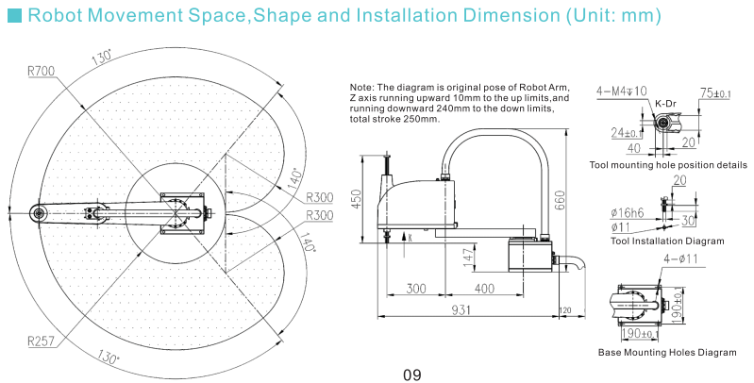
图片模糊，请提供清晰的图片

特征与功能：
- 标准循环时间为0.4S
- 臂长700mm
- 额定/最大负载：2/5KG
- 适配控制系统QC400A/QC410，支持多种通讯方式：串口、网络、USB等
- 小巧轻便，刚性高，易于系统设计、安装与维护，价格实惠、交期短

